**Trigger Workflow using API in aem**

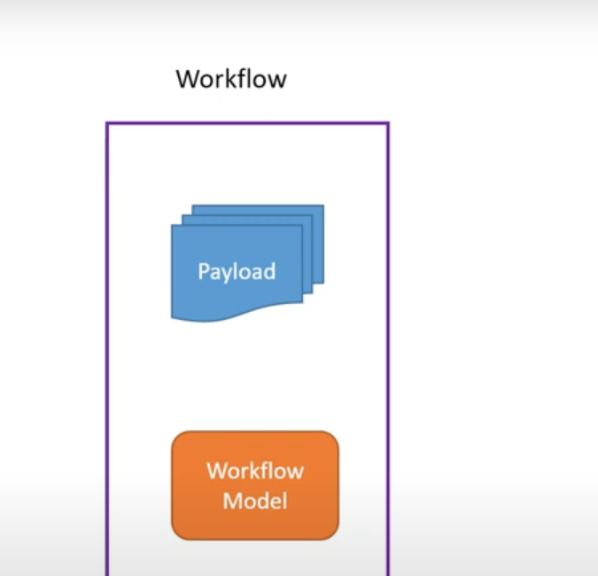

Workflow Model(wm):

Wm has all the code realted to the requirement

Payload:

On which path workflow model need to do work

We need this two thing to work on the workflow .

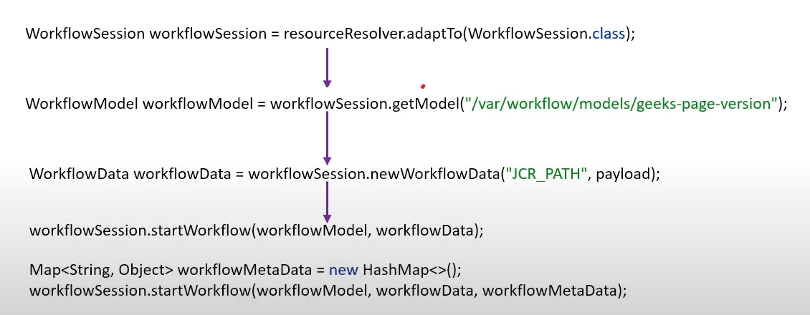

**WorkflowSession workflowSession = resourceResolver.adaptTo(WorkflowSession.class);**

**Here, resourceResolver is obtained through some means (e.g., a service, a context). This is then adapted to a WorkflowSession which is necessary for interacting with AEM workflows.**

**String workflowModelPath = "/var/workflow/models/geeks-page-version";**

**WorkflowModel workflowModel = workflowSession.getModel(workflowModelPath);**

**The workflowModelPath points to the location of the workflow model. This model defines the steps and logic of the workflow. The getModel method retrieves this model so it can be used to start a workflow instance.**

**String payload = "/content/my-site/new-page"; // This is the path to the new page.**

**WorkflowData workflowData = workflowSession.newWorkflowData("JCR_PATH", payload);**

**The payload in this case is the JCR path of the new page that has been created. The newWorkflowData method is used to create a WorkflowData object with this payload. The "JCR_PATH" type indicates that the workflow will operate on a JCR node.**

**Start the Workflow without Metadata:**

**workflowSession.startWorkflow(workflowModel, workflowData);**

**Starts the workflow using the model and data created in the previous steps. This initiates the workflow without additional metadata.**

**Create Metadata and Start the Workflow with Metadata:**

**Map<String, Object> workflowMetaData = new HashMap<>();**

**An empty HashMap is created for workflow metadata.**

**workflowMetaData.put("initiator", "user123");**

**workflowMetaData.put("status", "initiated");**

**Here, two pieces of metadata are added to the HashMap:**

**initiator: Represents the user who started the workflow. In this example, it is "user123".**

**status: Represents a custom status. In this case, it is "initiated".**

**workflowSession.startWorkflow(workflowModel, workflowData, workflowMetaData);**

**The startWorkflow method is called with three arguments:**

**workflowModel: The model of the workflow to be executed (e.g., /var/workflow/models/geeks-page-version).**

**workflowData: The data the workflow will process, such as the JCR path of the new page.**

**workflowMetaData: The metadata map containing additional information relevant to the workflow.**